Pilot test 44 respondents

DIM01 question 3 was update leaving the alpha with 0.38.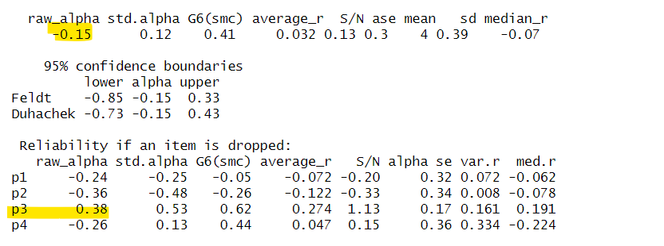

DIM02 ok

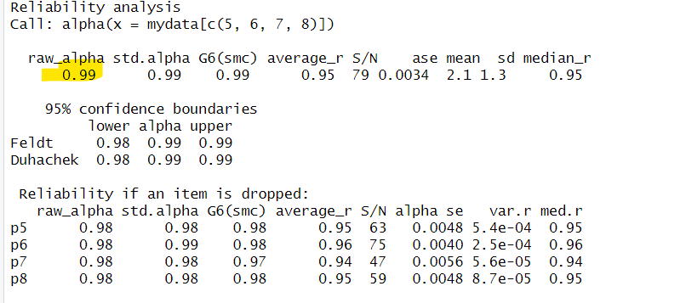

DIM03 ok

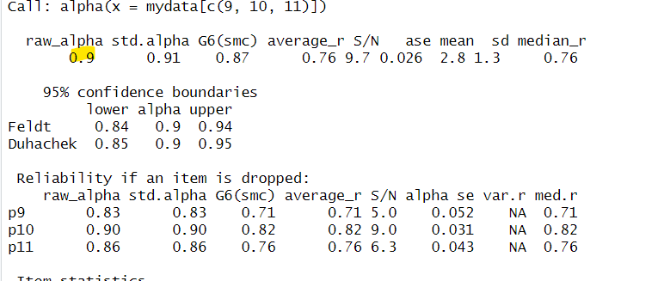

DIM 04, question 12 was update leaving the alpha with 0.73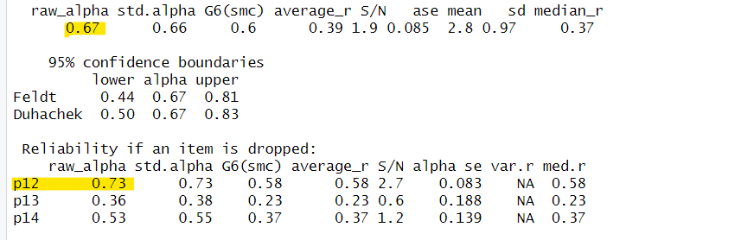

DIM 05 the entire dimension was removed

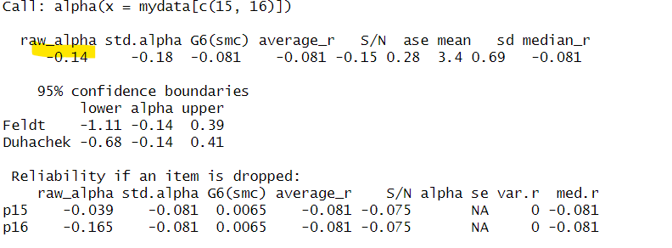

DIM 06 ok

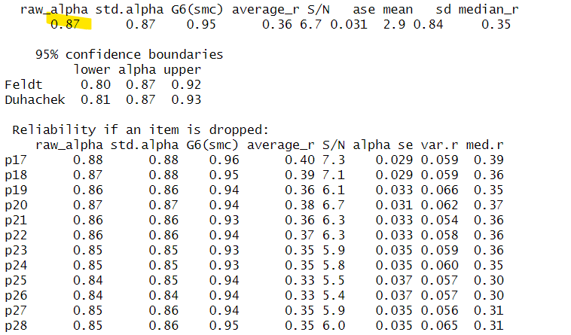

Dim 07, question 29 was removed leaving the alpha with 0.69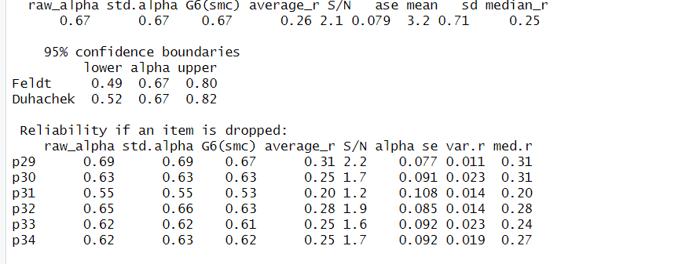

Pilot test 150 respondents

Dim1 ok

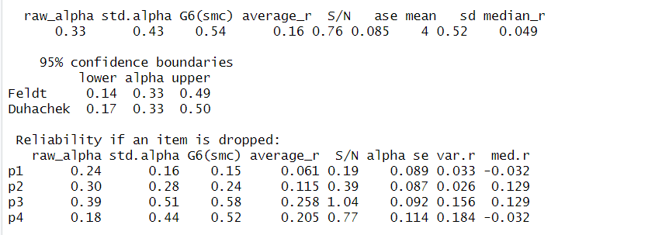

Dim 2 ok

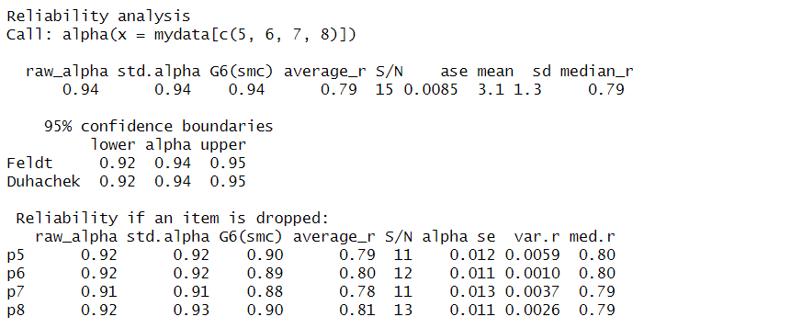

Dim3 ok

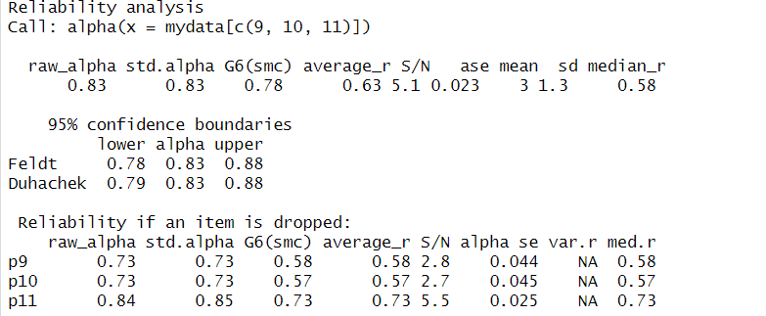

Dim 4 ok

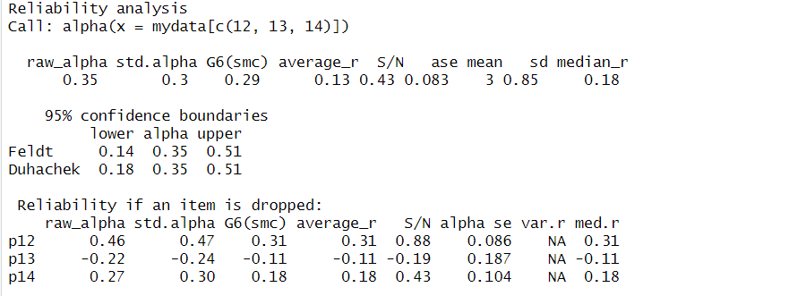

Dim6 ok

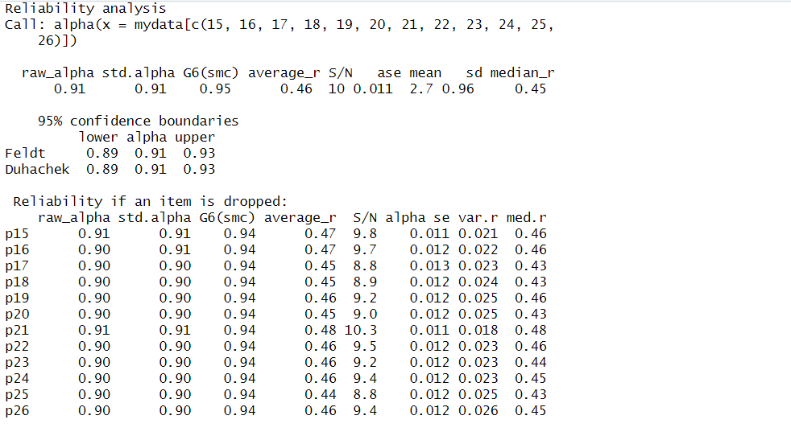

Dim 7 ok

